Poker Dice Game (Totally not Yahtzee)

Comp Sci 162

Project 3

4/2/2020

By

Chase Mulder

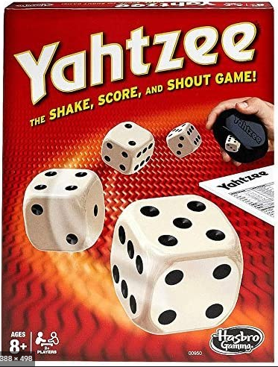

"I pledge that this work is entirely mine, and mine alone (except for any code provided by my instructor).”



Poker Dice Test

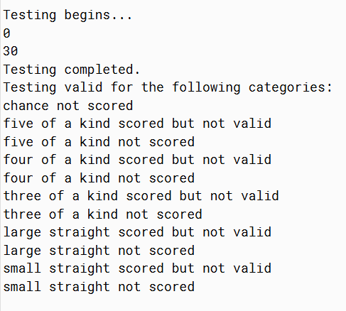

PokerJUnit

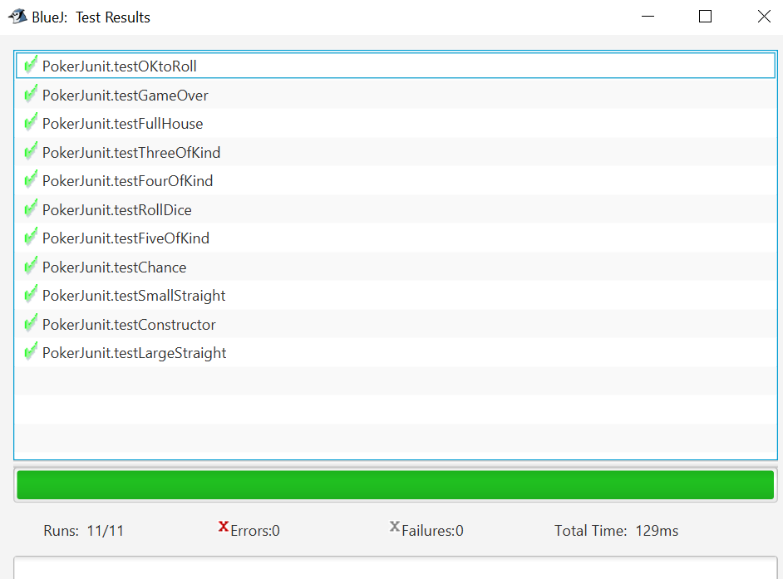

Initially Beginning the PokerGUI

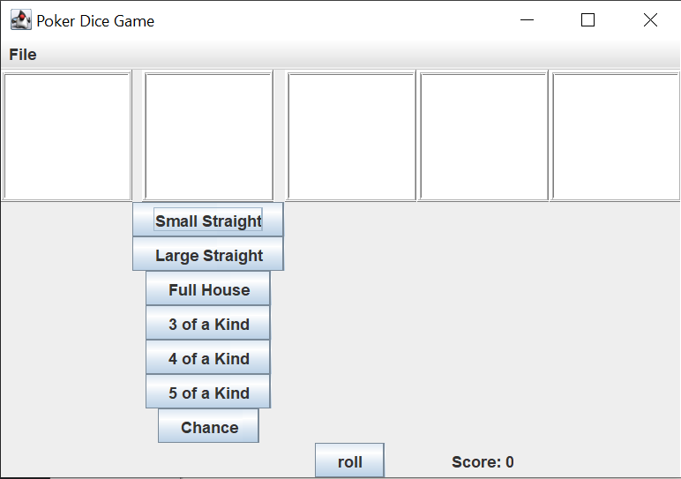

All Files in one folder

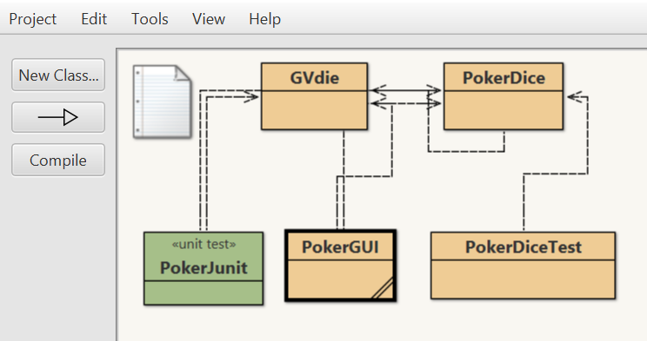

Functional 3 of a kind (15 points added to score)

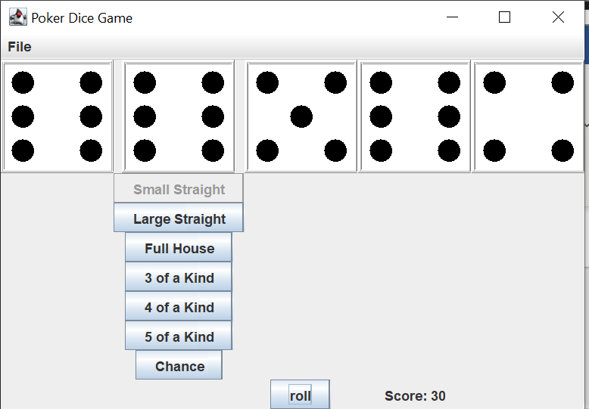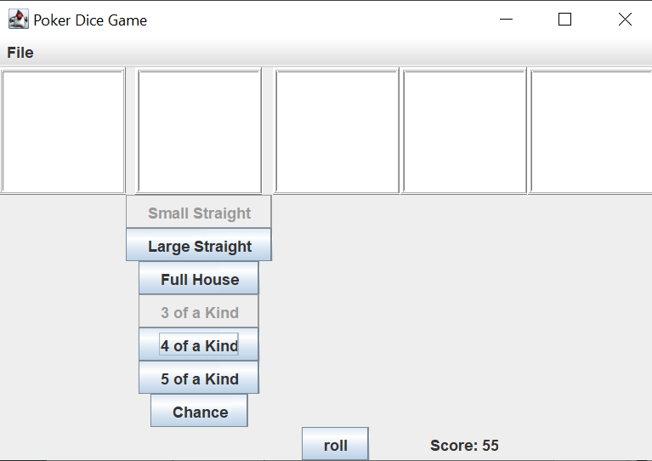

Chance functional (2+3+4+2+1 = 12)

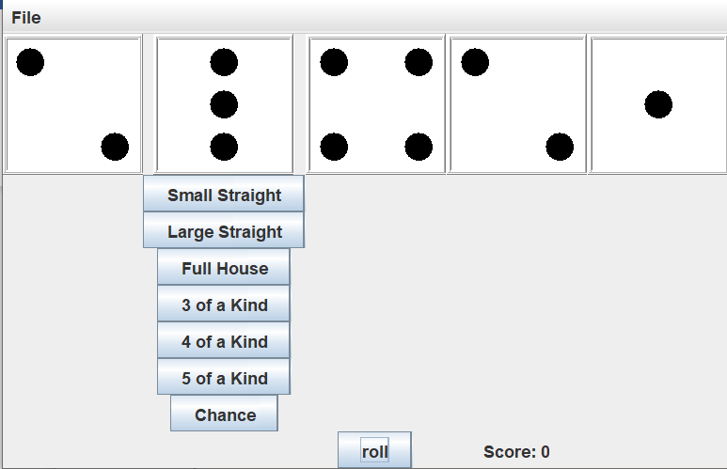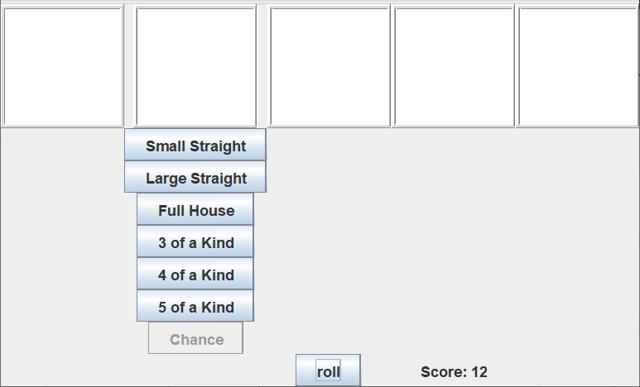

Functional 5 of a kind and use of holding of die

